Basic Number Concepts and Operations

Adult Basic Education
Developmental Math

Nathan Peterson
Central Lakes College
Staples Campus
npeterson@clcmn.edu

July 2017
Executive Summary

As of fall semester 2017, Central Lakes College Staples Campus in conjunction with Adult Basic Education (ABE) Central Minnesota-North (Consortium partner: http://stcloud742.schoolwires.net/Page/908) will be offering an Adult Basic Education math prep course to students with the primary need to increase their math skills, to prepare them for the math portions of the Accuplacer test, or to increase their Accuplacer math test results to better prepare them for math courses at Central Lakes College. All Robotics students that score 65 or below will be strongly encouraged to take this math course to better prepare them for the math that is used in basic electronics. This math course is to be modeled after the Robotics Automated Systems Technology (RAST 1114) Math for Industrial Technology course, which is no longer offered as a part of the Robotics Automated Systems Program.

The target audience for this math class will be both traditional and nontraditional students ranging in age from 18 to over 65. This course will align to the Central Lakes College course outline for Robotics’ Math for Industrial Technology. In the course outline, the following text book is suggested: McKeague, C. P. (2008). Elementary Algebra. CA: Brooks/Cole. (ISBN-13: 978-0-495-10839-9) This text book will be referenced in this text simply as the text book here after.

The college course outline also lists specific course outcomes as defined by the Central Lakes College Course Outline. Per this outline, “the student will be able to…”
- Manipulate SI engineering units;
- Demonstrate order of operations;
- Manipulate real number systems;
- Add, subtract, multiply, and divide fractions;
- Solve word or application problems;
- Simplify linear and nonlinear equations;
- Graph linear equations;
- Demonstrate polynomial addition, subtraction, multiplication, and division.

It is the intention of this document to provide lesson plans that incorporate learning activities that can be taught in this ABE math course that meet the course objectives listed above.
Table of Contents

Lessons
Lesson 1: Adding and Subtracting Decimals (1 days) 4
Lesson 2: Scientific Notation (1 days) 6
Lesson 3: Metric Prefixes (1 days) 9

Lesson 4: Notations and Symbols (2 days) 13
Lesson 5: Addition and Subtraction of Real Numbers (1 days) 15
Lesson 6: Prime Numbers and Factoring (1 day) 17

Lesson 7: Factions and Equivalents (3 days) 19
Lesson 8: Multiplication and Division of Fractions (1 day) 23
Lesson 9: Numbering Systems (4 days) 26

Appendix
Decimal +/- Board 31
Flats and Longs 32
Coin Game 33

How Grand is Your Total 34
Unit 19 – 21 Worksheet (unknown source) 36
Sample Conversion Test 37

Sample Test 1 38
Fraction Circles 39
Hundreds Chart 40

Binary Activity 41
Soup Recipe 42

Lesson 1: Adding and Subtracting Decimals (1 Day)

Objective: The student will be able to add and subtract decimal values and identify decimal place holder values. (Related to Course Objective 1 and 3)

Launch: How do decimal numbers work? If I have a quarter and a nickel in my pocket, how do we know how much money that is? A quarter is worth … 25 cents and a nickel is worth … 5 cents. What does that (cents) mean? How do you add the two numbers together when represented in dollars?

Explore:
- Review the names for the decimal place holders and discuss what they mean (up to three decimal digits). Relate “cents” to “century” to “hundredths”.
- Distribute “Decimal +/- Board” (see appendix) and explain how it works.
- Demonstrate to the students how the example discussed in the launch is applied to the worksheet.
  - First write out the problem in words.
  - Have the students make and estimate and explain how.
  - Have the students shade the boxes (note the groups of 10)
  - Have the students combine the pictures
  - Have the students write out the symbols and preform the math.
- Give a new addition problem (in words) in hundredths and have the students work/compare notes with partners. Example: 52 hundredths plus 7 hundredths.
- Give the students another new addition problem (in words), this time in thousandths, and have the students work/compare notes with partners. Example: 39 thousandths plus 116 thousandths.
- Give the students a couple of new problems using subtraction. Start with hundredths and work toward thousandths. Discuss with the students how you can use the decimal board to subtract (take away) decimals. Example: 90 hundredths minus 14 hundredths.

Share: Have the students share the results of both the addition problems and discuss various methods and results with class. Discuss how to create the thousandths digit on the Decimal Board and explore what it means and how to represent the digit. Have the students share their ideas on how to use the decimal board for subtracting decimals before they explore the problem.

Summarize: The big idea of this lesson is to understand decimal numbers, decimal placeholders and unit names, and how to line them up for addition and subtraction. A quarter was .25 and a nickel is .05, emphasize the .0 place holder to make the nickel worth 5 cents or 5 hundredths.

Assignment: Give and assignment for the students to work on outside of class:
- 56 hundredths plus 3 tenths
- 23 hundredths plus 58 hundreds
- 658 thousandths plus 17 hundreds
- 5 tenths minus 102 thousandths

Example Assessment Problem:
- 24 hundredths plus 31 hundredths

Lesson 2: Scientific Notation (1 Day)

Objective: The student will be able to represent numbers using scientific notation and powers of 10. (Related to Course Objectives 1 and 3).

Launch: Watch Powers of 10 video: (https://www.bing.com/videos/search?q=powers+of+ten+video&view=detail&mid=1F9980E1934E859E41CE1F9980E1934E859E41CE&FORM=VIRE) to get students thinking about extremely big and extremely small values. Reference the basic unit of charge, 1 Coulomb = 6.24 x 10¹⁸ electronics as an extremely large number.

Explore:
- Classroom activity:
  - The instructor draws a square (on a whiteboard) measuring 1mm by 1mm. Relate to 10⁻³ meters. How many powers of ten can we draw?
  - Have a student draw a second square over the first measuring 1cm by 1cm. Relate this to 10⁻² meters.
  - Have another student draw a third square over the first two measuring 10 cm by 10 cm. Relate this to 10⁻¹ meters.
  - Repeat until there is no more possible space to represent the next power of 10. Continue to relate each square to a power of 10.
- Discuss Scientific Notation and how it relates to the power of 10 video and exercise.
- Discuss the scientific notation format: m x 10^{n}, where 0 < m < 10
  - Example 1.23 x 10⁴.
- Review the following table. Discuss the positive and negative powers of 10 exponents.
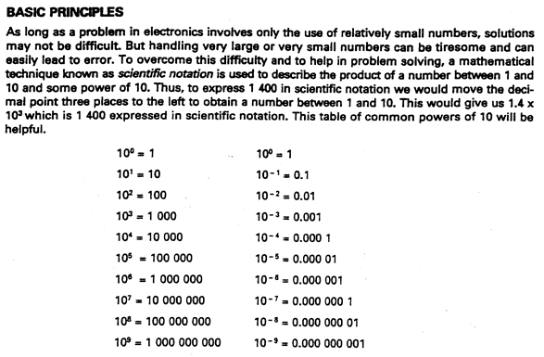

- Note the movement of the decimal place, for the positive exponent, then the negative exponent. Discuss what that represents. Does the number change in value? This is a big idea!
- Review Problems as class. Have students work with partners to discuss how to convert numbers to a scientific notation. Have a discussion about the purpose (and value) of the units. Make note of the “unusual” groups of three digits. Have the students speculate why, but give no answers today! Foreshadowing!

Share: Have the groups of students share their answers for each review problem with the entire class. Discuss various methods. Have a discussion about how to manipulate the decimal for negative exponents and/or small decimal values.

Summarize: Electrical quantities, such as current and resistance can be represented by extremely large or extremely small numbers. To write out the actual value would take up too much space! Refer to 1 Coulomb of charge (6.24 x 10¹⁸). We need to be able to represent these values in a simpler notation. Make sure everyone understands that by converting a real number into scientific notation does NOT change the value of the number.

Assignment: Unit 19 Worksheet on Scientific Notation. (see appendix)

Example Assessment Problem:
- Express the following in scientific notation:
  - 14 400 volts
  - .000 014 amps
- See Sample Conversion Test in the Appendix

Lesson 3: Metric Prefixes (1 Day)

Objective: The student will be able to use metric prefixes in converting unit values without changing the value of the number. (Course Objectives 1 and 3).

Launch: Ever hear of stories where someone mixed up and confused metric and standard measuring systems?
NASA lost a $125 million Mars orbiter because one engineering team used metric units while another used English units for a key spacecraft operation, according to a review finding released Thursday. For that reason, information failed to transfer between the Mars Climate Orbiter spacecraft team at Lockheed Martin in Colorado and the mission navigation team in California. Lockheed Martin built the spacecraft. "People sometimes make errors," said Edward Weiler, NASA's Associate Administrator for Space Science in a written statement. "The problem here was not the error, it was the failure of NASA's systems engineering, and the checks and balances in our processes to detect the error. That's why we lost the spacecraft." The findings of an internal peer review panel at NASA's Jet Propulsion Laboratory showed that the failed information transfer scrambled commands for maneuvering the spacecraft to place it in orbit around Mars. JPL oversaw the Climate Orbiter mission. "Our inability to recognize and correct this simple error has had major implications," said JPL Director Edward Stone. The spacecraft completed a nearly 10-month journey to Mars before it was lost on September 23. The navigation mishap pushed the spacecraft dangerously close to the planet's atmosphere where it presumably burned and broke into pieces, killing the mission on a day when engineers had expected to celebrate the craft's entry into Mars' orbit. Climate Orbiter was to relay data from an upcoming mission called Mars Polar Lander, set to set down on Mars in December. Now that mission will relay its data via its own radio and another orbiter. Both Mars Surveyor spacecraft were designed to help scientists understand Mars' water history and the potential for life in the planet's past. There is strong evidence that Mars was once awash with water, but scientists have no clear answers to where the water went and what drove it away. NASA has convened three panels to look into what led to the loss of the orbiter, including the internal peer review panel that released the Thursday finding. –CNN http://www.cnn.com/TECH/space/9909/30/mars.metric/
Why do we use Metric Prefixes? How do you convert 57 inches into feet?

Explore:
- Review Metric Engineering Prefixes:

Metric Prefix Chart
Name Abbr. Mult. Decimal Equivalent
pico p 10⁻¹² 0.000 000 000 001
nano n 10⁻⁹ 0.000 000 001
micro μ 10⁻⁶ 0.000 001
milli m 10⁻³ 0.001
base unit 10⁰ 1
kilo k 10³ 1 000
Mega M 10⁶ 1 000 000
Giga G 10⁹ 1 000 000 000
Tera T 10¹² 1 000 000 000 000

- Relate metric prefixes to powers of 10. Look for patterns. Note the “base unit”
- Activity:
  - The instructor draws a square on the board (about 750mm²). As a class, make multiple measurements of the same square in millimeters, centimeters, decimeters, and meters.
      - Mm = _(750)_ mm
      - Cm = _(75)_ cm
      - Dm = _(7.50_ dm
      - M = _(0.75)_ m
  - Big idea: How big is the square? Was the size of the square ever changed? How come there are 4 answers to how big the square is?
  - Distribute rulers to the class. Have them work in pairs. Have one make a rectangle on a piece of paper and have the other measure the rectangle length and width. Have the first student measure in millimeters and have the second student measure in centimeters. Have them compare results and share with the class.
- Example: Convert “ten micro amps into amps”
  - What is the base unit? (Amps or Amperes)
  - How do we represent ten micro amps (10 μA)
  - How do we represent micro amps in amps? (10 μA = 10 x 10⁻⁶ A = 0.000 010 A).
  - Do the spaces help? What do they mean? How do they relate to the comma in the number 10,000?
  - How do we know which way to move the decimal?
- Example: Convert “one hundred twenty seven mega ohms to kilo ohms.”
  - What is the base unit? (Ohms)
  - How do we represent one hundred twenty seven mega ohms? (127 MΩ)
  - How do we represent mega ohms? (127 MΩ = 127 x 10⁶Ω).
  - How do we represent kilo ohms? (1 kΩ = 1 x 10³Ω).
  - How do we convert? (127 MΩ = 127 x 10⁶ Ω = 127 000 x 10³Ω = 127 000 kΩ)
  - Do the spaces in the number help? Why?
  - How do we know which way to move the decimal?
- Have the students work together on the practical problems from the Unit 20 worksheet (see appendix).

Share: Have the students share the results of measuring the rectangle in millimeters and centimeters. Are the measurements the same? Address any discrepancies. Have the students acknowledge that the measurements are the same, but off by a factor of 10.

Once the students have completed the practice problems, have them share their answers. Have a discussion on why they moved the decimal in the direction that they did. Have them relate that as the powers of 10 exponents become more negative, the smaller the unit becomes. Example: one amp is one thousand times bigger than one micro amp. Although, you can’t feel or detect a micro amp, one amp will kill you!

Summarize: In electronics, we use very large and very small numbers. We represent these values through the use of metric prefixes. We use metric prefixes because each prefix in the chart listed above is a multiple of 1000. To move from prefix unit to prefix unit, we can simply move the decimal with no need for harder calculations (like changing from inches into feet). Note in the table of prefixes, all the “groupings of 3” line up. Point out the significance.

Big Idea: Although we changed 10 μA into 0.000 010 A, we didn’t change the amount of current being recorded. We simply changed the unit that we recorded in to eliminate the decimal. Relate this to the measurement of the rectangles.

Assignment: Complete the remaining problems on the handout. Unit 20 Worksheet on Equivalent Electronic Units. (see appendix)

Example Assessment Problem:
- 12 800 000 Ω = __________ MΩ
- .000 000 000 045 F = _______ µF
- See sample Conversion Test in the Appendix

Lesson 4: Notations and Symbols (2 days)

Objective: The student will be able to demonstrate using common math symbols and the math order of operations. (Related to Course Objective 2).

Launch: Suppose you have a checking account that cost you $10 per month, plus 5 cents for every check you write. If you write 10 check, then your monthly charge would be: 15 + 10 x .05. How do you calculate this? Is your charge $15.50 or $1.25? That’s a big difference, isn’t it? Which is correct and why?

Explore:
- (Day 1) First, some definitions:
Comparison Symbols
Equality a = b a is equal to b
a ≠ b a is not equal to b
Inequality
a < b a is less than b
a ≤ b a is less than or equal to b
a > b a is greater than b
a ≥ b a is greater than or equal to b
Operation Symbols
Addition a + b The sum of a and b
Subtraction a – b The difference of a and b
Multiplication a*b, (a)(b), a(b), (a)b, ab The product of a and b
Division a ÷ b, a/b, a/b The quotient of a and b

Grouping Symbols
Parentheses ( )
Brackets [ ]
Braces { }

Rules of Operation
Parentheses
Exponents
Multiplication and Division
Addition and Subtraction

Please Excuse My Dear Aunt Sally
- Divide the class into pairs. Have them work on example problems given in the text book chapter 1.1. Have the groups demonstrate how they solved the problems.
- (Day 2) Demonstrate how to play Who Wants to be a Hundredaire! http://www.math-play.com/Order-of-Operations-Millionaire/order-of-operations-millionaire.html Have the students go to the computer lab and play one round. (Pair up if needed).
- Demonstrate how to solve and answer the questions for the first “Applying the Concepts” question from chapter 1.1 of the text. Have the students work together in groups of two on the remaining problems. Have the student groups report out at the end of the class period.

Share:
- Have the student groups explain how they went about solving the example problems for the text book before class ends. They should use the vocabulary that was discussed at the beginning of class. Have them highlight the orders of operation.
- Have each student share there experience playing the computer game, Who Wants to be a Hundredaire!
- Assign each student group to demonstrate how they solved the Applying the Concepts problem. Encourage a discussion on other methods for solving the same problem.

Summarize: Symbols are an important tools we use to communicate math and math operations. They are just as important as words and it is just as important that we understand the meaning of symbols.

How we solve math equations is just as important as understanding the meaning of math symbols. Math equations have a specific order of operations they are intends to be solved in. Just like making a sandwich. You need to apply the butter before adding the meat.

Assignment:
- (Day 1) Assign Problem Set 1.1 from the text Book
- (Day 2) Assign Applying the Concepts from chapter 1.1 from the text book.

Example Assessment Problem:
- 10 – 2(4 * 5 – 16)
- 3⁴ + 4² ÷ 2³ – 5²
- See Sample Test 1 in the Appendix

Lesson 5: Addition and Subtraction of Real Numbers (1 Day)

Objective: The students will be able to add and subtract real numbers both positive and negative. (Course Objective 3).

Launch: “We’re going to play a game!”
- Coin Game (see appendix). See Game Board Number Line Below.
    - Separate into pairs. Each pair needs a cup, ten pennies, and two game markers.
    - Both players place their markers at 0.
    - Alternating turns, each player will shake the cup of pennies and dump them on the desk.
    - Each “heads” means you will move your marker left (or positive).
    - Each “tails” means you will move your marker right (or negative).
    - The first person to get past + or – 6 wins! (or if there is no winner after 10 turns, the player closest to +6 or -6 wins!)

Game Board:

<-----|------|------|------|------|------|------|------|------|------|------|------|------|---->
-6 -5 -4 -3 -2 -1 0 1 2 3 4 5 6

Explore:
- How do you organize you pennies after you shake? Do you place the “heads” together and the “tails” together? What happens when you have more “tails” than “heads”?
  - Write down shake results as math statements. Example: four heads and six tails is 4 + (-6) =
  - How do you add these numbers together?
- Incorporate the examples from the text book (Ch 1.3) such as:
  - 12 + 17
  - 12 + (-17) =
  - -12 + 17 =
  - 12 + (-17) =

Be sure to talk about why the parenthesis are around the -17 and what that means.
- Introduce the definition of an arithmetic sequence: a sequence of numbers in which each number (after the first number) comes from adding the same amount to the number before it.
  - Example: 2, 5, 8, 11, …

Share: Have the students share strategies for playing the coin game. What was the quickest way to decide where to place the marker? Were there numbers that you can’t land on? Why?

Summarize: The coin game introduced us to adding numbers both positive and negative. We learned if the negative number is larger, the marker moved left because the negative number became larger (or smaller depending upon how you want to address it).

Assignment: Problem Set 1.3 from the text book. (odd)

Example Assessment Problem:
- (-9 + 2) + [5 + (-8)] + (-4)
- See Sample Test 1 in the Appendix

Lesson 6: Prime Numbers and Factoring (1 Day)

Objective: The student will be able to distinguish prime numbers from composite number and be able to factor prime numbers from composite numbers. (Related to Course Objectives 3, and 5).

Launch: Mathematicians LOVE prime numbers because just about all of math is made out of prime numbers. In the same way, scientists LOVE atoms because just about everything we know is made out of atoms.

Explore:
- Define Prime Number: any positive integer larger than 1 who’s only positive factors (divisors) are itself and 1.
- Define Composite Number: any positive integer greater than 1 that is not prime.
- Prime Number Hunter activity. Distribute Hundreds Chart (see appendix). https://www.education.com/activity/article/Prime_Number_Hunter_fifth/
  - Have the students select a partner. Distribute one Hundreds Chart to each group and a different colored pen for each student. Tell them not to follow the directions on the chart, but follow these directions:
  - To play, the students will be competing to cross out all the composite (nonprime) numbers, and circle all the prime numbers. Designate one color pen for each student.
  - Each player will take turns either crossing out a composite number (1 point), circling a prime number (3 points), or “passing.” The game will get easier as more numbers are crossed and circled, but the bigger numbers may present more of a challenge to the student.
  - Once all the numbers are circled or crossed out, the player with the most points wins!
- Define Factor: If a and b represent integers (may need to define integer), then a is said to be a factor (or divisor) of b if a divides b evenly, or if a divides b with no remainder.
- Demonstrate how to factor numbers into prime factors. Use example problems listed in chapter 1.8 of the text book.

Share:
- Have the students share the results of the Hundreds Work Sheet. Have them explain how they were able to determine if a number was composite or prime. Did anyone cross out or circle the number 1? Is it composite or prime? Refer to the definitions.

Summarize:
Composite numbers can be factored into prime into a set of prime number multiples. Prime numbers are special because the only two numbers you can multiply together is 1 and the prime number. All other positive numbers (except 1) are composite, meaning they can be factored into prime numbers. Later on, we will use this concept to determine things like how to figure out a least common denominator for a fraction.

Assignment:
- Problem Set 1.8 (odd) from the text book.

Example Assessment Problem:
- Label the following numbers prime or composite: 48, 72, 37, 23
- Factor the following into the product of primes: 144, 102, 63

Lesson 7: Fraction and Equivalents (3 days)

Objective: The student will be able to recognize fraction equivalents and be able to add and subtract fractions. (Related to Course Objective 4).

Launch: Play this video: Attention Getter to Factions.

Explore:
- (Day 1) Fraction Circles from The Rational Number Project. Distribute the Faction Circles worksheet (see Appendix), markers (or colors), and scissors. Have the students color the circles and cut them out. (Or you could print on colored paper if available.)
- Explore the following questions (from The Rational Number Project):
  - How many browns equal 1 whole black circle?
  - 1 whole black circle equals how many pink pieces?
  - How many reds equal 1 whole black circle?
  - How many pinks equal 1 whole brown piece?
  - 1 brown piece equals how many red pieces?
  - 1 brown is (less than, equal to, greater than) 1 pink?
  - 1 red is (less than, equal to, greater than) 1 brown?
  - 1 yellow is (less than, equal to, greater than) 1 brown?
  - 1 yellow, 1 brown, and 1 _____ equals 1 whole black circle.
  - 1 yellow equals 1 brown and 2 ____?
  - 3 pink and 1 _____ equal 1 whole circle.
  - ______ grays and 1 blue and 1 yellow equals 1 whole circle.
  - 2 grays and ______ blue equal 1 yellow.
  - 1 pink equals _____ red.
  - 4 _____ equal 1 yellow.
- (Day 2) Create Fraction Strips. Have the students each create 11 fraction strips. Materials needed: 1 piece of paper, 1 ruler, 1 scissors each. Cut 11 strips of paper 8 ½ (the width of a page of paper) by 1 inches (you should be able to get 11 from one page). With the first strip, have the students fold it in half to make a crease. Mark the crease with a line and label it ½. Fold the second strip in thirds and mark each crease ¹/₃ and ²/₃. Fold the third strip in half and half again and mark each crease ¼, ²/₄, and ¾. Continue process for fifths, sixths, skip sevenths, eighths, ninths, and tenths.
- Once the fraction strips are complete, have the students transfer all fraction strip marks to one “master” fraction strip. Have them label all marks and note all the fraction equivalents. Why is ½ and ²/₄ and ³/₆ and ⁴/₈ and ⁵/₁₀ all on the same mark? Why is thirds or fifths or ninths on this same mark?
- Discuss ways on adding fractions together. Encourage the students to use the number strips to mark on another sheet of paper in order to “measure out” the solution. Example: ½ plus ¼, on another sheet of paper, mark a starting point, measure ½ and make a mark. From that mark, measure ¼ and make another mark. Measure the total with the fourths fraction strip and you should see that the total is ¾.
  - If you add ¹/₃ and ¹/₃ you should get (²/₃).
  - What if you add ½ and ¼? How can you add them together? Recognize that you can convert ½ into ²/₄ and now you can add ²/₄ and ¼ to equal ¾.
  - How can you add ³/₅ and ³/₁₀ together? What is the result?
  - What happens when you add ²/₃ and ⁵/₉ together? What happens? What should be done?
- Have the students work together in groups of two and assign them to work on the practice problems from chapter 1.9 of the text book. When they have completed them, have them share with the class on their answers.
- (Day 3) Define Addition and Subtraction of Fractions: If a, b, and c are integers (talk about what integers are) and c is not equal to 0, then
a/c + b/c = (a + b)/c and
a/c – b/c = (a – b)/c
- Define Least Common Denominator (lcd): a set of denominator (identify denominator) is the smallest number that is exactly divisible by each denominator. (Note: Sometimes this is called the least common multiple.) In other words, all the denominators of the fractions involved in a problem must divide into the least common denominator exactly, that is, they divide it without giving a remainder.
  - Relate this least common denominator to the fraction strips and how they were finding solutions to the problems from yesterday. Example: ½ + ¼ = ²/₄ + ¼ = ¾. The common denominator is 4. Also relate this example to a, b, and c from the definition. If a = 2 and b = 1 and c = 4, then a/c + b/c = (a + b)/c or ²/₄ + ¼ = ⁽² ⁺ ¹⁾/₄ = ¾.
- Demonstrate how to find LCD. Be sure to explain that when we find a common denominator that we also have to change the numerator (define numerator) by the same amount to keep the fraction equivalent. Again, compare to the fraction strips.
- Demonstrate how to use LCD to add and subtract fractions.
- Have the students work in groups on Problem Set 1.9 from the text book.

Share:
- (Day 1) Have each students select a color of the fraction circle and compare how it relates to the black circle and have them relate it to another color.
- (Day 2) Have each group explain how they solved an example problem, of their choosing using the fraction strip or the fraction circle.
- (Day 3) During the remain 10 minutes of class select random problems from the assigned work and have each student group explain how they found a common denominator and how the converted the numerator and solved the problem.

Summarize:
Before we can begin adding and subtracting fractions, we first need to understand what fractions are and how they have equivalents that equal the same amount. Using the fraction circle, we can see that the black circle is the entire unit (or base unit if we want to compare to previous lessons). The colors are parts of the whole. If you have two equal parts that make up the whole, these are called halves. If you have three equal parts that make up the whole, these are called thirds.

The fractions strips are a good way to represent fraction equivalent and prepare students to find common units (denominators) before they can combine the fractions. Many students are familiar with the concept of the tape measure. These fractions strips are similar because each strip is one unit and the fractions are a part of the hole. Much like inches are on the tape measure.

The first step in adding and subtracting fractions is recognizing that you must have common units (or denominators) before adding or subtracting. Hopefully, the fraction strips have shown the students that, or at least, the common equivalents. From there, students should begin to recognize the need for a common denominator and have seen when a denominator changes (for example from 2 to 4) the numerator also needs to change (for example from 1 to 2).

Assignment:
- (Day 1) Construct fraction circles.
- (Day 2) Construct fraction strips.
- (Day 3) Assign Problem Set 1.9 from the text book.

Example Assessment Problem:
- ²/₃ – ¼
- ⁵/₁₂ + ⁷/₁₈ – ¼
- See Sample Test 1 in the Appendix

Lesson 8: Multiplication and Division of Fractions (1 day)

Objective: The student will be able to multiply and divide fractions. (Related to Course Objectives 4).

Launch: Nate ate lunch at the cafeteria of the hospital. He had he soups and it was the best soup he had ever had. He asked the cooks for the recipe and they gave it to him. Nate went home and wanted to cook the soup, but soon realized that the soup recipe was for 75 people. That is a lot of soup. How can Nate make only enough for him, say 5 servings?

Explore:
- Multiplication with fractions is super easy, you just multiply straight across and reduce (if needed).

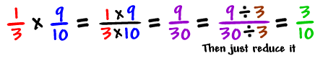

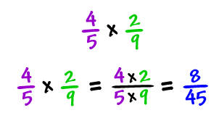
- Think about it. If we had a pizza cut into 10 slices and removed 1 slice we would have 9 left. If I wanted 1/3 of the remaining, how many would that be?
- Here’s another example:

- Dividing fractions are just as easy: you just flip and multiply:

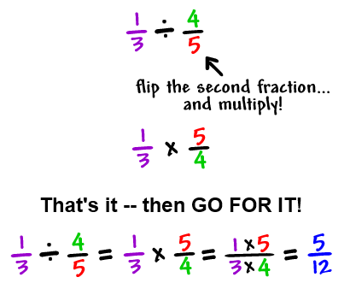

- Explore the soup recipe dilemma from the launch. Distribute the Soup Recipe (see appendix) and have the students work in groups to determine what quantities of each ingredient is needs.
- Have students work together in groups and as a class on the assignment given below.

Share:
- Have the students share the results they got from converting the Soup Recipe. Have them explain if they divided or multiplied and why?
- Have the students demonstrate solving multiplication and division of factions from the assignments on the board. Have students take turns demonstrating at the board.
- Near the end of the class period (10 minutes) have the class reflect and facilitate a discussion on these questions:
  - Why is it that when you add and subtract fractions, you need a common denominator, but when you multiply fractions you don’t?
  - Why is it that when you divide fractions, you can flip the second fraction and multiply them together?
  - When dividing fractions could you flip the first one instead of the second? Why not? What is the result if you try?

Summarize: First, don’t be afraid of fractions. Multiplication and division of fractions are easy! For multiplication, you simply multiply straight across and for division you flip the second fraction and then multiply straight across. After the multiplying, you need to check to see if you can simply. You simply by finding the greatest common factor of both the numerator and the denominator, then you simple divide both by that number.

Assignment:
- Problem Set 1.6 from the text book.
- Problem Set 1.7 from the text book.

Example Assessment Problem:
- Multiply: -6/5 * 2/7
- Divide: 7/10 ÷ 5/6
- Simplify: 8(-1/4x + 1/8)
- See Sample Test 1
Lesson 9: Numbering Systems (4 days)

Objective: The student will be able to convert decimal number system into other numbering systems including binary and octal and vise a versa. (Related to Course Objectives 2, 3, and 4).

Launch: Most people understand us when we say we have nine pennies. The number 9 is part of the decimal number system we use every day. But digital electronic devices use a number system called binary. Digital computers and many other digital systems use other number systems such as octal or hexadecimal. Men and women who work in electronics must know how to convert numbers from the everyday decimal system to the binary, octal, and hexadecimal systems.

Explore:
- (Day 1) Activity: Cut out the flash cards (or create your own) from the Binary Activity (see appendix). Have four students hold the cards in the front of the class room. They need to be in a specific order, from left to right: the flash card with 8 dots, 4 dots, 2 dots, and 1 dot. Have all students hold the cards with the backside facing the classroom. This will represent the binary number 0000. Each backside of the card has zero dots. (source https://www.youtube.com/watch?v=b6vHZ95XDwU)
  - Now have the students represent the binary number 0001. Have the first three students keep the backside to the class, but the fourth student turn over the card. Count the dots. Binary 0001 equals a decimal number 1.
  - Now represent another number such as binary number 0111. Have the first student keep the backside showing to the class, but the other three students turn their cards over and count the dots. 0 + 4 + 2 + 1 = 7 dots. The binary number 0111 represents the decimal number 7.
  - Try another binary number such as 1010. Turn the card over to the dot side if a 1 is indicated, turn the card to the backside if a 0 is indicated. Count the dots. The binary number 1010 equals 8 + 0 + 2 + 0 = 10.
- Explore the meaning of the decimal numbering system and what the placeholders represent.
  - Discuss the meaning the digits in a decimal number, for example 127. What does the 1st digit represent? (how many hundreds) What does the 2nd digit represent? (how many tens) What does the 3rd digit represent? (how many ones)
  - In reality, we refer each digit to ones, tens, hundreds, and thousands, but have you ever realized they represent multiplies of 10. You can relate this to the powers of 10 from an earlier lesson. The ones digit is really 10⁰, the tens digit is really 10¹, the hundreds digit is really 10², and the thousands digit is really 10³. The decimal number system is really called the base 10 number system.
- The binary system works the same way, but it is the base 2 number system. This means that the units or digit have changed values. They are the ones digit, the twos digit, the fours digit, the eights digit, just like the flash cards in the activity. In this case, the ones digit is 2⁰; the twos digit is 2¹; the fours digit is 2²; the eights digit is 2³. Very similar to the base 10 system!
- Have the students work together in groups of two to complete the assignment 1 listed below and report at the end of the class.
- (Day 2) How do you go from decimal to binary? You have to think about the binary digits. If you have a decimal number, for example 13, what is the largest binary digit you can take away? An eights digit. 13 – 8 = 5 remaining. Can you take away a fours digit from the remaining 5? Yes, 5 – 4 = 1 remaining. Can you take away a twos digit from the remaining 1? No. Can you take away a ones digit from the remaining 1? Yes, 1 – 1 = 0. So, you took out 1 eights digit, 1 fours digit, 0 twos digit, and 1 ones digit = 1101 in binary.
  - Have the class try converting 15 from decimal to binary. 1 eights digit and 1 fours digit and 1 twos digit and 1 ones digit equal 1111 in binary.
  - Have the class try converting 25 from decimal to binary. 1 sixteens digit and 1 eights digit and 0 fours digit and 0 twos digit and 1 ones digit equals 11001
- Have the students work together in groups of two to complete the assignment 2 listed below and report at the end of the class.
- (Day 3) Octal Numbering system, or base 8. In computer systems, we talk about the binary number system. In reality, each digit represents one bit (of information). You really can’t really share much information, so in the earlier days of computers, we group bits together in groups of 3. A group of three bits gives us 8 different characters that we can represent in each digit. This is called octal or base 8.
- Activity: Convert octal to decimal. Have the students replicate the first activity by selecting four volunteers. Have the four students each take a blank sheet of paper and the first will label the paper “The Ones Digit” and write “x1”. (Note: x means times). The second student will label their paper as “The Eights Digit) and write “x8”. The third student will label their paper as “The 64’s Digit) and write “x64”. The fourth student will label their paper as “The 512’s Digit) and write “x512”.
  - Select an octal number such as 12. (Remember octal numbers are limited to only 0 – 7 in each digit.) Ask the class how many 512’s digit are there? (0) How many 64’s digit are there? (0) How many eights digit are there? (1) How many ones digit are there? (2). Write the results on the board and in the equation:

512 x 0 + 64 x 0 + 8 x 1 + 1 x 2 = have the students to the math (10)

  - Try another octal number such as 127. Have the students determine how many of each unit (or digit) there are.
127 octal = 64 x 1 + 8 x 2 + 1 x 7 = 87 decimal
  - Try another octal number such as 7654. Have the students determine how many of each unit (or digit) there are.
7654 octal = 512 x 7 + 64 x 6 + 8 x 5 + 1 x 4 = 4012 decimal
- Have the students work together in groups of two to complete the assignment 3 listed below and report at the end of the class.
- (Day 4) How do you convert from decimal to octal? Relate to how you converted from decimal to binary. List (horizontally) the octal units as placeholders on the board. (512) (64) (8) (1). Given the decimal number 48, what is the largest placeholder value you can take out? (8) How many “8s” can you take out? (6) How many are remaining? (48 – 8 x 6 = 0) How many “1s” can you take out of the remaining 0? (0) The octal number is 60
  - Have the students try converting decimal 128 to an octal number. (128 – 64 x 2 + 8 x 0 + 1 x 0 = 0) 200
- Have the students work together in groups of two to complete the assignment 4 listed below and report at the end of the class.

Share:
- (Day 1) Have the students who held the flash cards in the activity describe what if was like being a placeholder for a binary number. Ask the students how many digits they think we could have gone? Ask them how many digits are in the largest decimal numbering system? Obviously, binary numbers are infinite like decimal numbers like all numbering systems. The one thing that continues to increase is the number of the exponent of the base.
- (Day 2) Converting from decimal to binary is relatively simple, because you are always looking to find the largest binary value that can be “taken away” of subtracted from and marking each “take-a-way” as a 1. If you don’t “take-a-way” for a digit it is marked as a 0. Have students share and demonstrate how they went about solving the questions in assignment 2.
- (Day 3) Have the students relate to the decimal number system and have them explain what the digits mean. What does a 2 in the hundreds column actually represent. Help them relate to what a 2 represents in the third digit of an octal number. Instead of the hundreds digit, it is the 64’s digit. A 2 represents 2 times 64 which is 128 while a 2 in the hundreds digit of a decimal number represents 2 times 100 which is 200. Have the students share their results from the assignment 3 questions.
- (Day 4) Sometimes it is harder to convert from decimal to another base because the students have to determine the unit value of each digit and determine how many units can be taken from the decimal number. Be sure to have students share example and demonstrate how they were able to solve some of the questions in assignment 4.

Summarize: There are many numbering systems that are in use today. We explored the binary and octal numbers systems. Others include the hexadecimal system which is base 16. There are two version of the ASCII code which the earlier version is base 128 and the new version is base 256. These are the bases that computer software systems use represent characters like the ones you are currently reading and the emoji’s that you incorporate into your text messages (that is why we needed the extended ascii system). Computer processors today commonly operate on base 64 system.

To understand numbering systems, you must first understand our numbering system, the decimal or base 10 system. Recognize that each digit is actually 10^{x} where 10 is the base and the exponent x is the digit number and the number equals the sum of all the digits. All numbering systems work this way.

Assignment:
- Convert the following numbers from binary into decimal.
  - 1 f. 1000 0000
  - 100 g. 1 0101
  - 101 h. 1100 1100
  - 1011 i. 1 1111
  - 1000 j. 1111 1111
- Convert the following number from decimal to binary
  - 0 f. 64
  - 1 g. 69
  - 18 h. 128
  - 25 i. 145
  - 32 j. 101
- Convert the following numbers from octal into decimal.
  - 1 f. 506
  - 31 g. 556
  - 64 h. 667
  - 356 i. 454
  - 517 j. 532
- Convert the following number from decimal to octal
  - 0 f. 64
  - 1 g. 65
  - 7 h. 128
  - 8 i. 960
  - 32 j. 770

Example Assessment Problem:
- Convert the base 10 number 77 into base 2
- Convert the base 10 number 77 into base 8
- Convert the base 2 number 1011 0111 into base 8
- Convert the base 8 number 127 into base 2

Appendix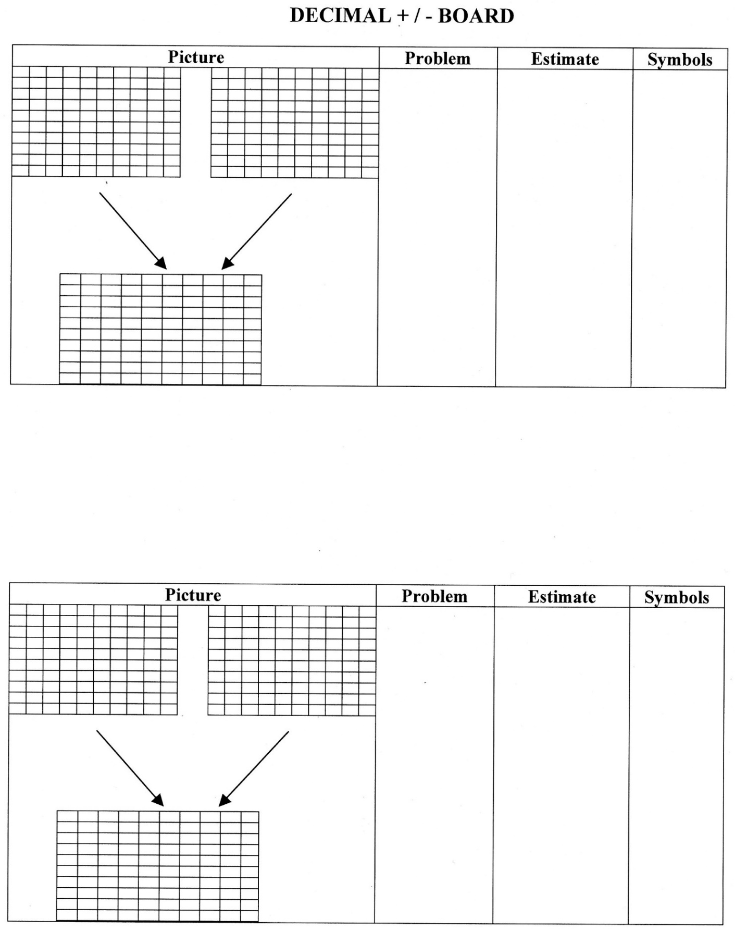
Flats and Longs

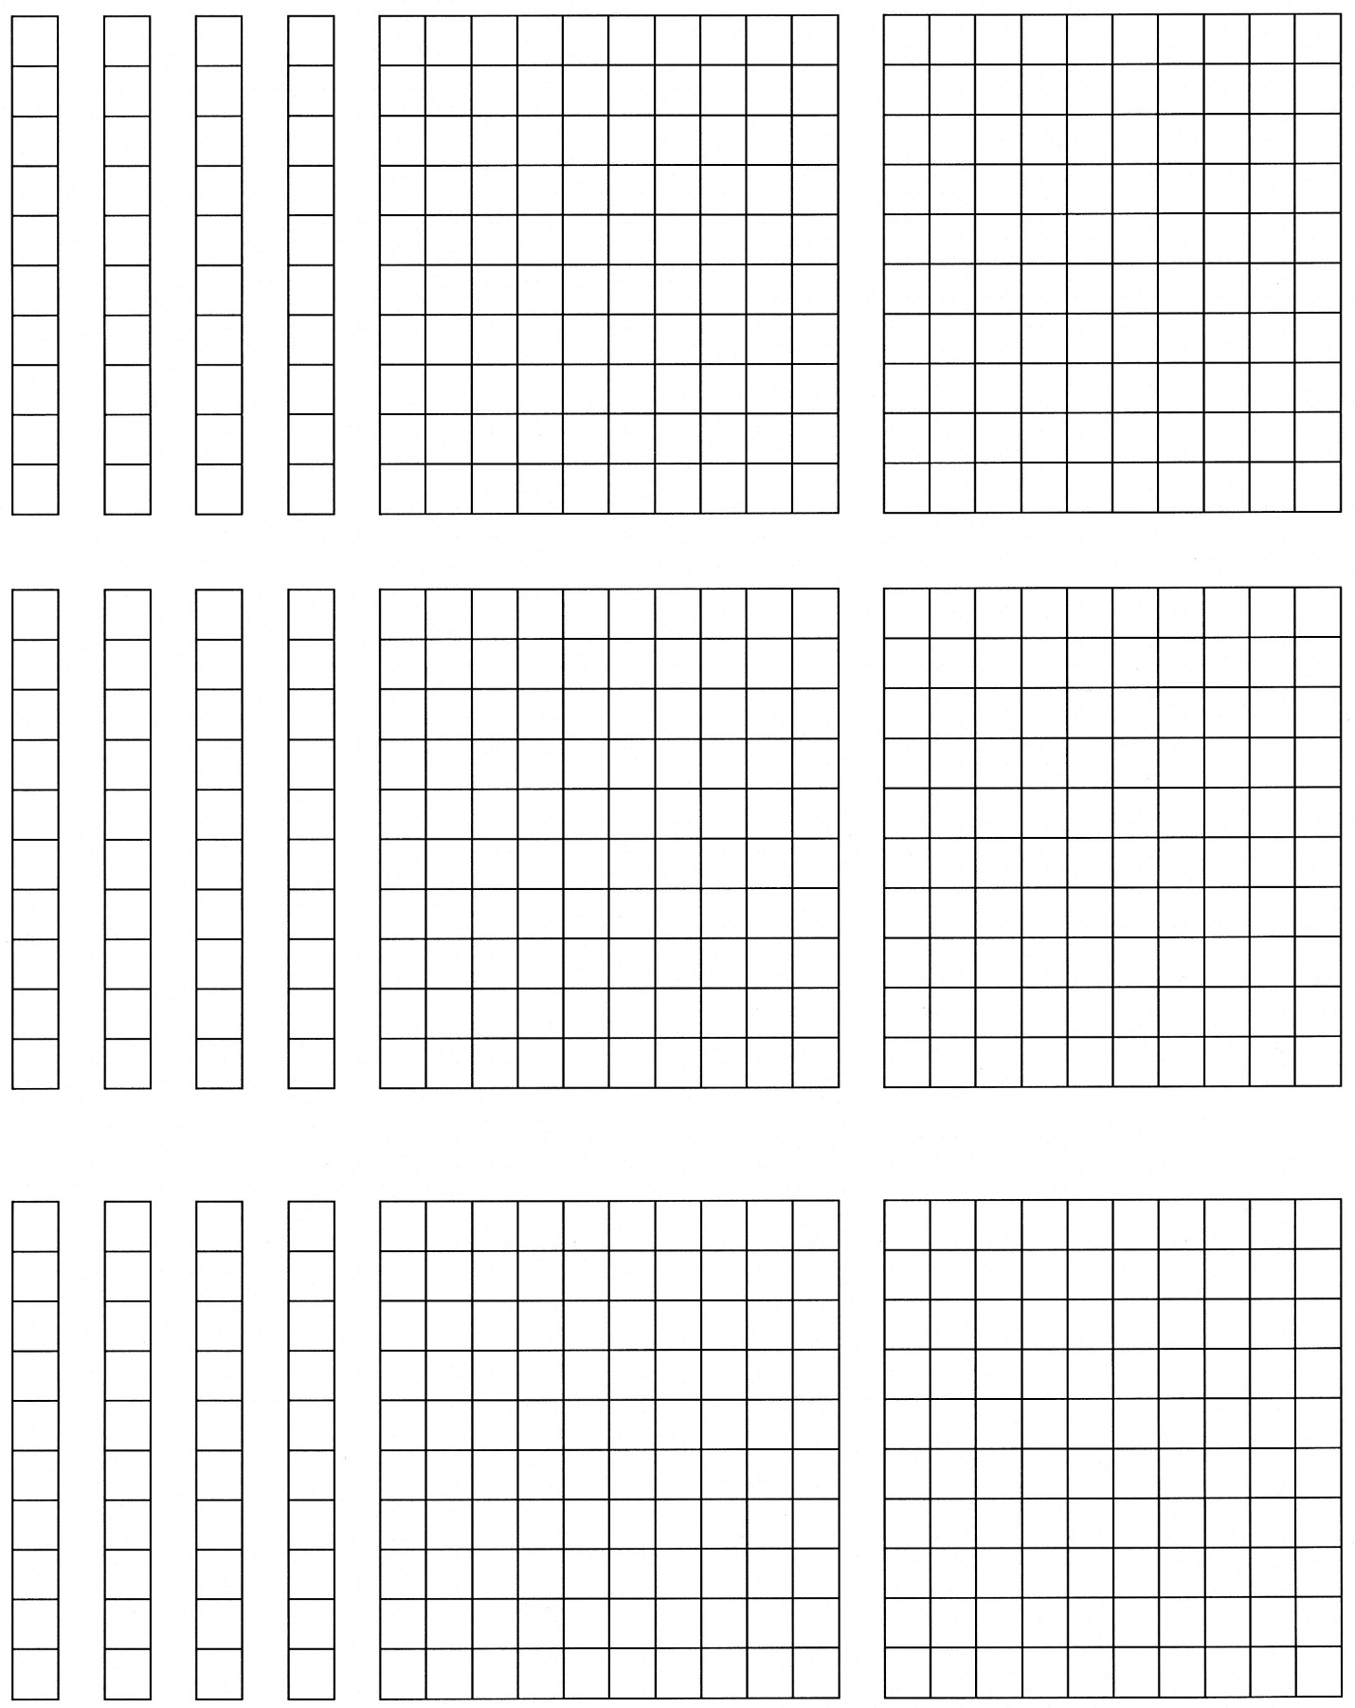
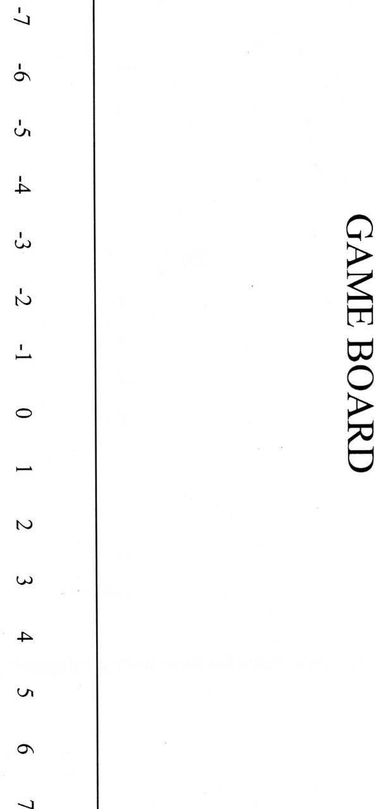
Coin Game
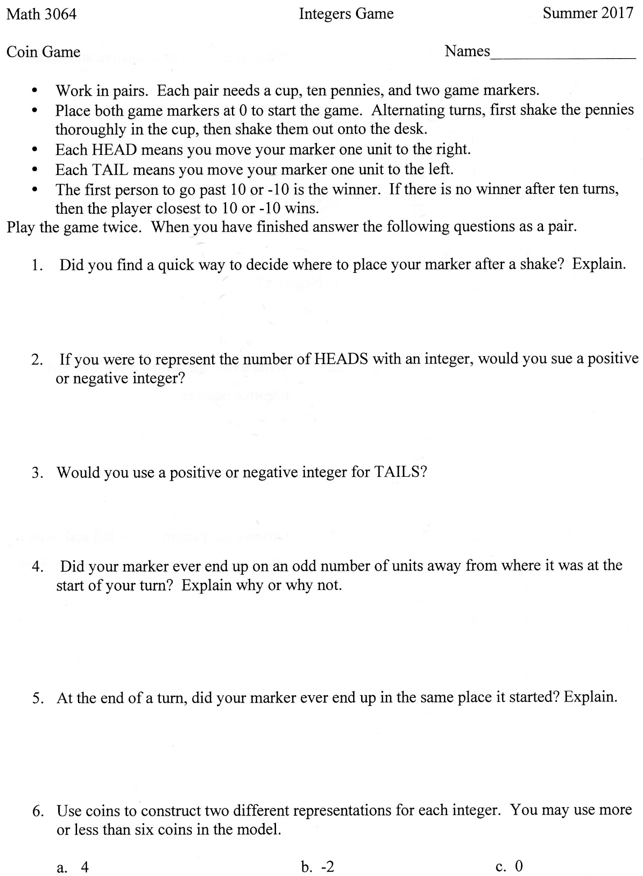
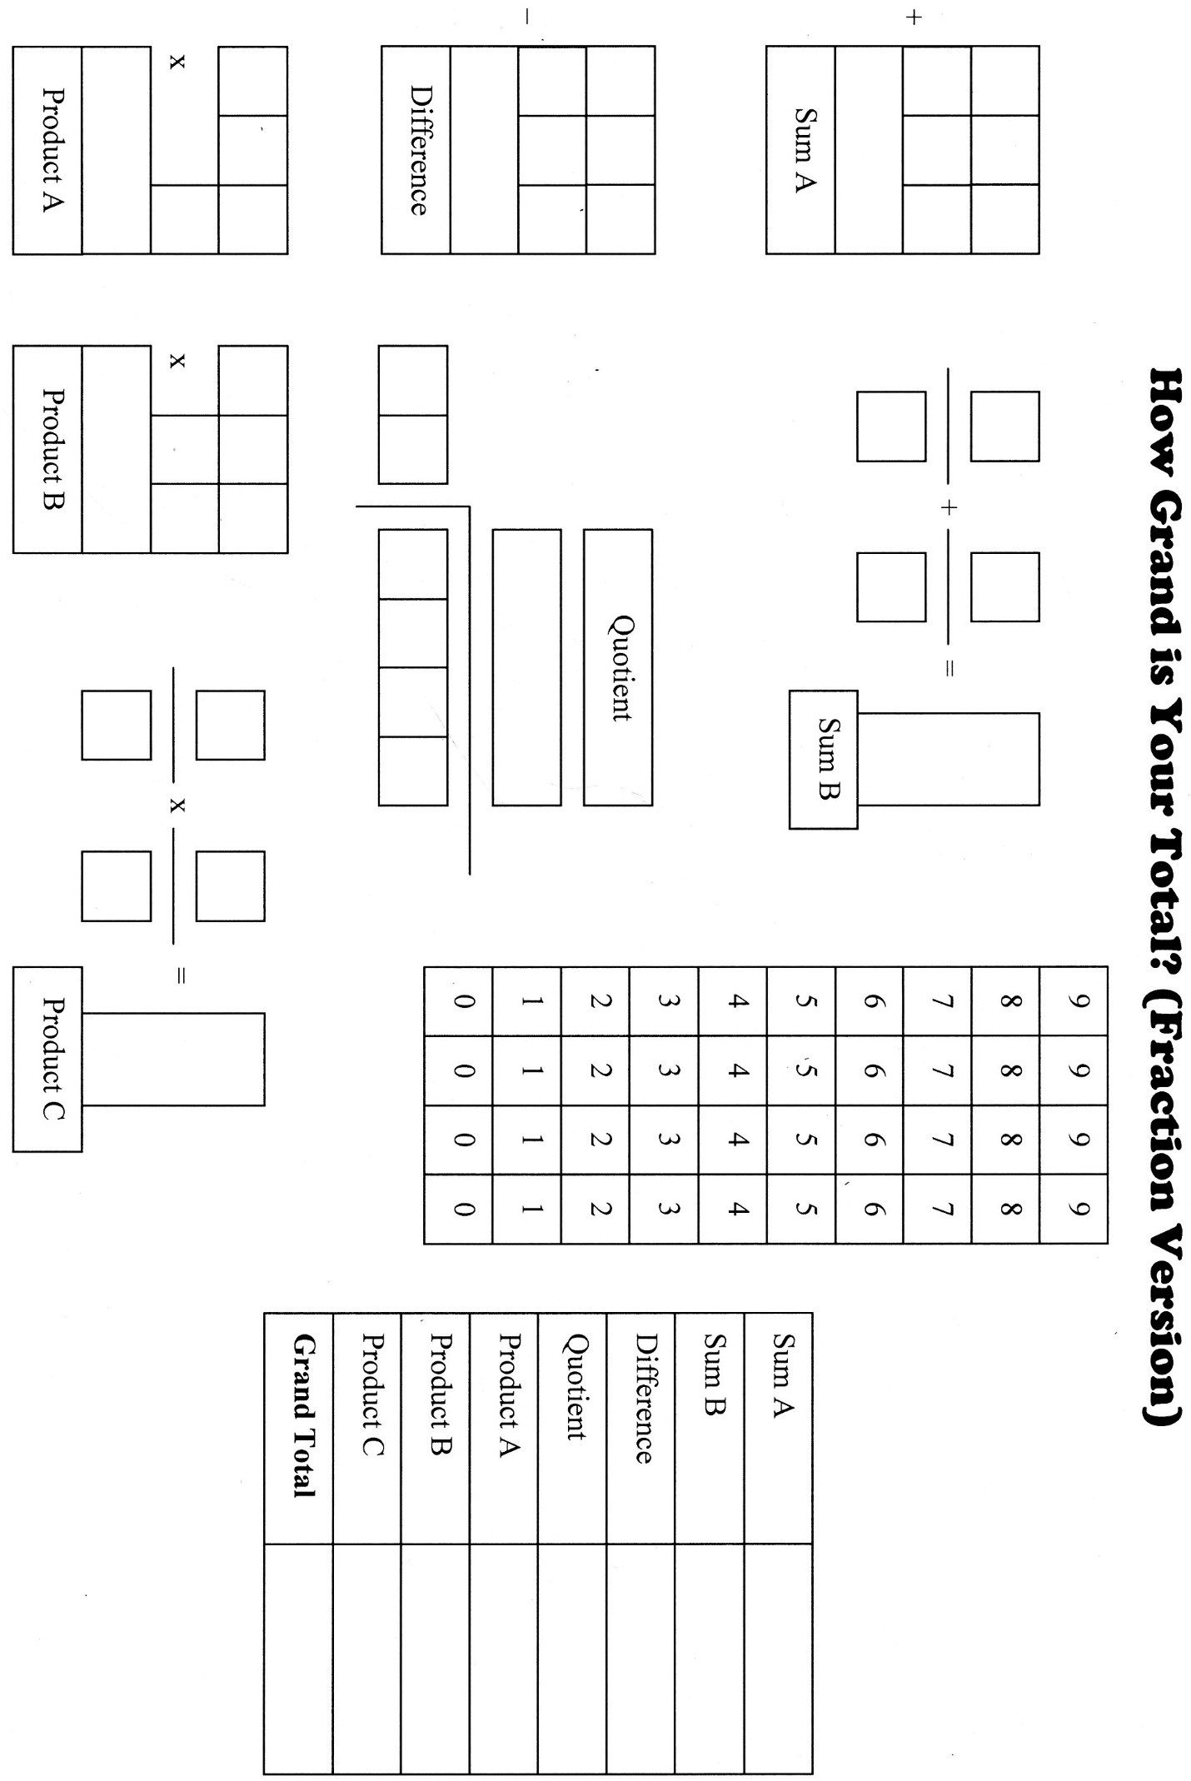
Unit 19 – 21 Worksheet (unknown source)
(Double click on image to view entire image)

Sample Conversion Test
(Double click on image to view entire image)

Sample Test 1
(Double click on image to view entire image)

Fraction Circles
(Double Click on the image to view entire document)
Source: The Rational Number Project
Hundreds Worksheet from education.com
(Double click on image to view as .pdf)

Binary Activity

